Neocortex Understanding Documents (laminar study)

Name – Subham Singh

Neocortex is a sheet roughly 2-4 mm thick wrapped over the brain. It has two types of organisations at once: horizontal layers (laminae) and vertical columns.
There are 6 layers in our neocortex, numbered from the pial surface¹ (the outer boundary of the cerebral cortex where the brain tissue meets the pia mater and cerebrospinal fluid). to the white matter² (bottom):
L1: molecular layer. Almost no cell bodies. It is a wiring layer; it holds the apical tufts of pyramidal neurons whose bodies sit deeper, plus long-range horizontal axons carrying top-down/feedback signals. Nothing computes here in the classical sense. – This is the place where the feedback arrives on the apical dendrites.
L2/3 : Supragranular, small to medium pyramidal neurons. Their axons are the main corticocortical feedforward output – they project to the next cortical area up the hierarchy.
L4: Granular layer, Spiny stellate cells(round densely crowded cell bodies) and small pyramids. This is the main thalamic input layer – first order (driver) thalamic afferents terminate here. ( main point of feedforward in).

L5: Infragranular – Large, thick tufted pyramidal neurons, this is the main subcortical output to the brain stem, spinal cord, striatum, superior colliculus, and higher order thalamus. “ Motor/output out”.
L6 – infragranular - Pyramidal neurons provide corticothalamic feedback ( back to the thalamus) and a loop back to L4 that modulates gain.
The canonical flow
1. Thalamus (relay station of our brain) ->L4->The driver input lands.
2. L4->L2/3 – Feedforward within the column.
3. L2/3 -> L5 , and in parallel L2/3 -> Other cortical areas.
4. L5 -> Subcortical targets and -> L6.
5. L6 -> thalamus (feedback)
- Corticothalamic loop – L6 sends feedback down to the thalamic relay cells that feed the column. Purpose: it modulates the thalamus’s own gain/gating – The cortex tells its own input source how much to pass through. This is the cortex closing a loop with its input.
6. L6->L4 (modulatory loop)
- Intracortical modulatory loop – L6 projects back up to L4 within the column. It modulates the gain of the driver input as it enters, biasing how strongly the incoming thalamic drives is expressed in L4.
So the intracolumnar spine is: L4->L2/3 ->L5->L6, with L6 closing loops back to L4 and the thalamus.

Two core principles:
1. Recurrence Dominates:
Most synapses onto a cortical neuron come from other cortical neurons in the same area, not from the thalamus. Thalamic drive is numerically small but electrically powerful – it is a driver that recurrent intracortical circuitry then amplifies and shapes. The cortex is mostly talking to itself.
Take any excitatory neuron in the cortex and count where its synapses come from: only a small fraction, ~5 to 20%, depending on layer and area, comes from the thalamus (the so-called outside-world input). The large majority come from other cortical neurons in the same local area. Neurons wire back onto each other in loops. That looping back is a recurrence.
Why it’s built that way - A feedforward only system (input->process-> output, no loops) can only react to what’s present right now. Recurrence lets the network hold and manipulate state that isn’t in the current input:
- Memory Over time - Activity can sustain itself after the input is gone, because neurons keep re-exciting each other. A pattern can “echo”.
- Prediction – recurrent connections let the network pre-activate the representation it expects next, before the input arrives. ( Temporal memory does it right now: predicted cells are recurring in action).
- Pattern Completion- Give the loop a partial noisy input, and the recurrent connections fill in the rest by settling into a familiar stable pattern.
- Amplification - A weak input can be boosted into a strong, sustained representation because the network re-excites itself.
The consequence of how we read the cortex, the thalamic input is not “the signal being processed”. It’s more like a seed or a nudge dropped into a gigantic self-sustaining recurrent network. The network’s own state – shaped by learning, context, and what happened a moment ago does most of the shaping of the output. This is why the same sensory input can produce different cortical responses depending on context: The recurrent state differs.
Observed behaviour from HALO : The baseline reliability of HALO collapses to the 0.01 floor on the random input. Random noise has no temporal structure, so the recurrent ( predictive) machinery has nothing to lock onto, hence the loop cannot perform its job. Structured/ Sequential data is what gives the recurrence something to predict.

2. Driver vs Modulator :
Upon discussing principle 1, the question that comes to our mind is, “If only ~10 per cent of the synapses are thalamic, how does the outside world control the cortex at all? Wouldn’t it get drowned out by the 90% internal processing(chatter)?”
The answer to that question lies in the fact that not all synapses are equal. Two connections can land the same number of synapses but do completely different jobs. Therefore, Sherman and Guillery formalised this into two classes :
i. Drivers: Connections that impose a representation. They say “fire like THIS” properties:
- Large Synapses, often clustered on the proximal dendrite(close to the cell body -> strong electrical effect).
- Activate Ionotropic receptors -> fast, powerful, reliable postsynaptic response.
- Carry the actual “content” – the “what” of the signal.
- For example, first–order thalamic axons onto L4. Also L4->L2/3.
ii. Modulators – Connections that adjust how a neuron responds to its drivers, without dictating the outcome. They say ‘be more/less sensitive’ or “shift your gain” “bias towards this”. They have the following properties:
- Smaller synapses, often on distal dendrites(far from the cell body-> weaker direct drive).
- Recruit metabotropic receptors˘(a type of G-protein coupled receptors that do not form an ion channel pore. They act indirectly by activating G-Proteins, which then initiate intracellular signalling cascades.) slow sustained, changes the cell’s state rather than forcing a spike.
- Example: feedback via L1 Apical dendrites; L6->L4 corticothalamic loop; neuromodulators like dopamine/acetylcholine.
Thus the numerical count, tells us almost nothing about the influence. A driver connection with few synapses can dominate the cell’s output, while a modulator connection with many synapses only tilts it. So principle 1(“Thalamus is outnumbered”) and the fact that “the world still controls perception” are not exactly in conflict – the thalamic input is outnumbered but still it’s the driver, so it punches far far above its synaptic weight(strength of the connection between two nerve cells or nodes).

Section II
Cortical Cell Types :
Our cortex has fundamentally two types of job categories, cells that excite ( push targets/neurons towards firing) and cells that inhibit ( push targets/neurons away from firing)- and the inhibitory side further splits into a smaller number of special families that execute different tasks at different locations on the target neuron.
- Excitatory Neurons
  - They take up the ~80% of the cortical neurons.
  - Neurotransmitter – Glutamate –opens channels that depolarise the target postsynaptic neuron, pushing it towards its threshold and if the threshold is crossed to an action potential.
  - Morphology. - Mostly pyramidal cells (triangular body, one long apical dendrite going up towards L1, several basal dendrites spreading sideways, a long axon that leaves the local area), Plus the spiny stellate cells in L4.
  - Projection: Long-range – They send axons to other layers, other cortical areas, and subcortical targets; they carry the content.
- Inhibitory Neurons
  - Neurotransmitter: Gamma-aminobutyric acid. It is the primary inhibitory chemical messenger in the human central nervous system, which opens up the channels that hyperpolarise (~ -90 mV) or shunt the postsynaptic target neuron, hence pushing it away from threshold.
  - Morphology: Non-pyramidal, no apical dendrite pointing to L1, usually smaller. Often called interneurons because they are local, their axons stay within the local circuit and don’t project long-range. They shape the local computation rather than sending the content elsewhere.
  - Only 20% of the cells, but they control when, how sparsely and where on the dendrite excitation is allowed to happen. They are in a small population with enormous control.
  - GABAergic interneurons are not all the same. They are further classified by a molecular marker – a protein the cell expresses that we can stain for, which reliably predicts what the cell looks like and what it does. Three families cover the large majority; these three are:
    - PV- Parvalbumin- (a calcium-binding protein).
      - Morphology – Basket cells and chandelier cells.
      - Target Region: Perisomatic (around the soma) Region – the cell body(soma) and the axon initial segment of their target pyramidal neuron.
      - Why this location: Near the soma and axon hillock region( the initial segment of the axon where the area inside the cell gets compressed) are the places where the spike is decided. Inhibition landing there gives the edge at the decision point – fast, powerful, controls whether and exactly when the cell fires. PV Cells are also fast spiking (they fire very rapidly, producing sustained trains), so they impose precise timing and determine how sparse the active population is.
    - From HALO’s point of view, This will set the encoding sparsity as well as the spike timing.
    - SST – Somatostatin – Expressing (~30%)
      - Marker: Somatostatin.
      - Morphology: Martinotti cells( axon climbs up towards L1 and branches out).
      - Where they target: The distal dendrites – The far, thin, branchy parts of the pyramidal neuron, especially up in the apical tuft of L1.
      - Why this location: Distal dendrites are where top-down/feedback/contextual inputs arrive (this is where the feedback lands) . SST cells sit exactly there and control whether those dendritic inputs are integrated or suppressed – They gate the contextual stream, and they control how far the dendritic activity spreads and how long it persists, they are slower and more accommodating than PV.
    - VIP – Vasoactive – Intestinal- Peptide-Expressing (~15%)
      - Marker: VIP
      - Morphology: Small bipolar cells.
      - Target Area: Mostly other interneurons - Specifically SST cells(and some PV). VIP inhibits the inhibitors.
      - Disinhibition - If VIP shuts off SST, the pyramidal neuron’s dendrites are released from SST’s braking or inhibitory effects -> top-down signals get through more strongly. VIP is the switch that says “ Let the context in right now” Often driven by attention. Neuromodulatory/ cross area signals.

Current HALO state :
- The current cortical unit is one glutamatergic population with no interneurons at all, so there is no PV to set sparsity/timing, no SST to gate the apical/contextual stream, no location specific interneuron does at a specific location and none of them can even be stated in the current architecture because the architecture has no interneurons and no dendritic compartments for them to target as of now.

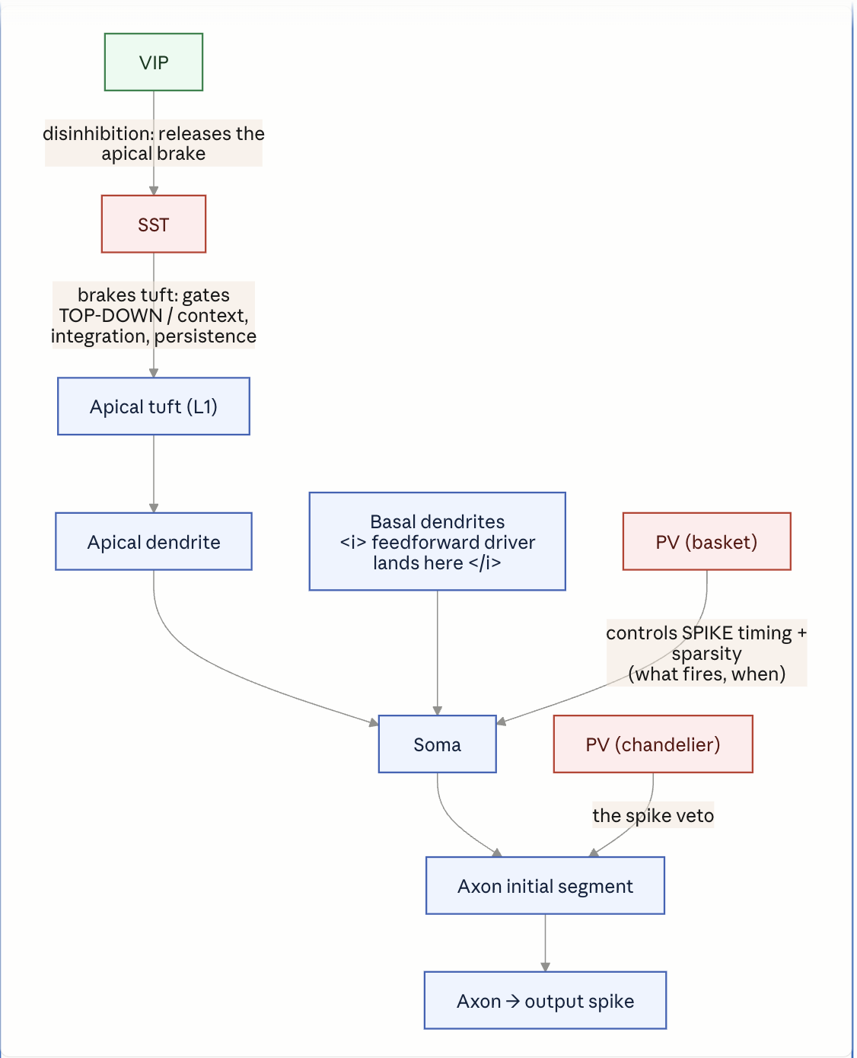

Now we will see what PV does that SST doesn’t and vice versa,
1. PV (Parvalbumin) – The output-side controller.
Marker: Parvalbumin, a calcium-binding protein. Correlated (not causally) with fast-spiking physiology via Kv3-type potassium channels – brief action potentials, very high sustained firing rates.
Morphology - Two canonical types. Basket cells and chandelier cells.
Location on the pyramidal target: The perisomatic zone. Basket cells wrap the soma and proximal dendrites; chandelier cells target the axon initial segment (AIS) itself. This is the region right at or next to the spike trigger zone.
Function follows directly from that location. Because PV synapses sit on the soma/AIS they act on the pyramidal cell’s integrated output- after all dendritic input has summed, at the point where the decision to fire is made. Two consequences:
- Timing: In a feedforward motif, the incoming excitatory volley drives PV cells fast and hard; PV then clamps the same pyramidal population within a couple of milliseconds. This opens a narrow window between excitation arriving and inhibition shutting it – pyramidal cells can only fire inside that window. PV set when firing is allowed.
- Sparsity/gain: Feedforward PV inhibition scales with the drive. Stronger input recruits proportionally stronger perisomatic inhibition, which caps how many pyramidal cells cross threshold. PV sets how many fire.
2. SST (Somatostatin) – The input side controller
Marker: somatostatin, a neuropeptide.
Morphology: Canonically the Martinotti Cell – ascending axon that climbs to L1 and arborises there.
Location on the pyramidal target: the distal/apical dendrites and tuft – the compartment in L1 where top-down feedback and contextual input land. Opposite end of the neuron from the PV. Function again follows location. SST acts on dendritic integration, before signals reach the soma. It gates whether apical/contextual input is allowed to generate dendritic events (NMDA/Ca²⁺ dendritic spikes) that would otherwise drive or bias somatic firing. Two consequences:
1.Spread/selectivity - SST Controls which contextual inputs on the apical tree are integrated versus suppressed – it shapes the content the dendrite is allowed to pass, not the timing of the output spike.
2. Persistence – SST/ Martinotti synapses onto pyramidal cells are typically facilitating – they build up under sustained, repetitive firing. So SST is recruited by ongoing activity and feeds back to control how long a dendritically driven pattern persists.

Therefore, to summarise. We can say

PV inhibits at the output to decide whether and when the cell fires; SST inhibits at the apical input to decide whether contextual signals get integrated and how long they persist- one gates output, the other gates input.

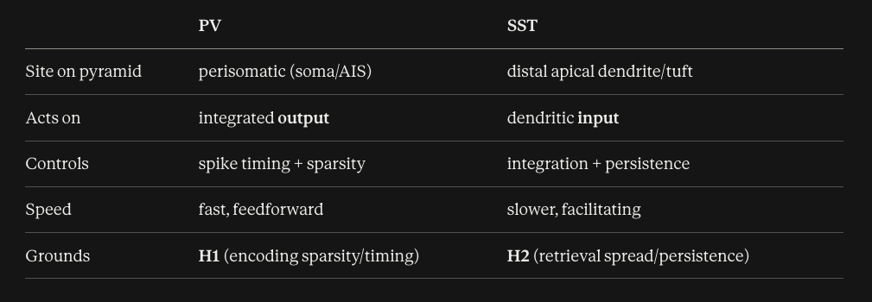

Note :
Contrary to the above table, PV and SST are not strongly divided by the location, but the two roles bleed into each other:
- SST touches on encoding, because what the apical dendrite integrates during the encoding pass helps determine which cells join the assembly in the first place. Dendritic gating is not purely a retrieval-time operation.
- PV touches retrieval, because when an assembly is reactivated by a top-down cue, its output still has to be timed and kept sparse – perisomatic control doesn’t switch off just because the drive is internal rather than feedforward.

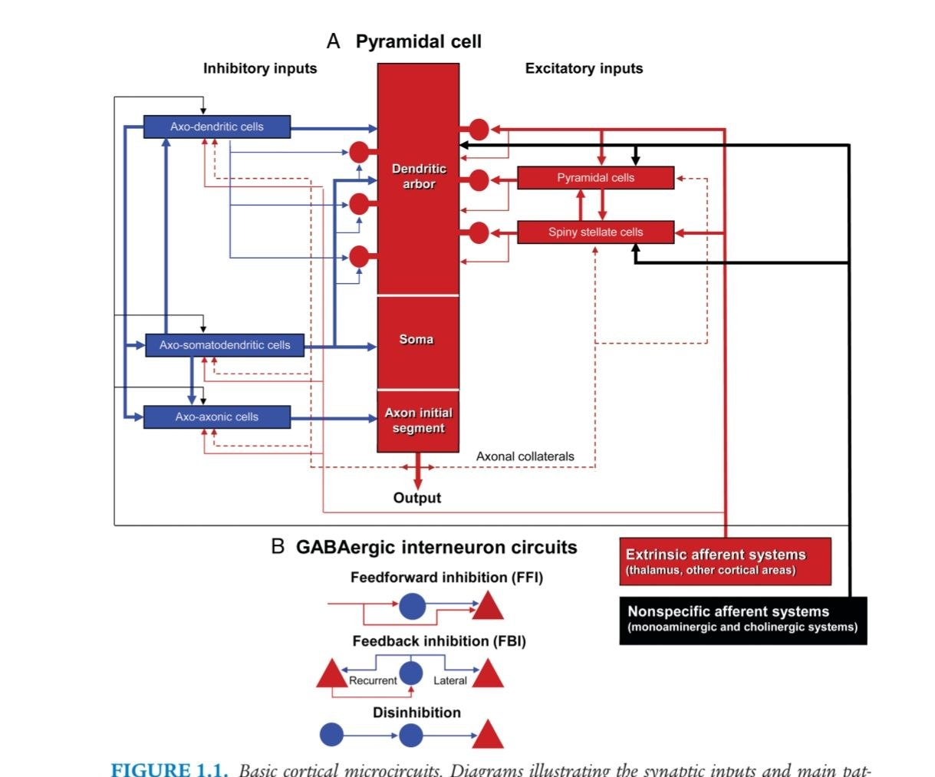

Description of the picture above:
- The central red bar(Panel A) is a single pyramidal cell, drawn as its compartments stacked from top-to -bottom.
  - Dendritic arbour (top) – Where input is collected.
  - Soma (middle) – Where the input is summed.
  - Axon initial segment(axon hillock ) – The spike trigger zone.
  - Output(the arrow leaving) – The axon carrying the result away.
- The left column(blue, inhibitory inputs) is the location principle made visual.
  - Three inhibitory cell classes, each named based on where its axon lands on the pyramidal cell.
    - Axo-dendritic cell- synapses onto the dendritic arbour (top). Input-side control.
    - Axo- Somatodendritic cells – Synapse onto the soma(middle) . Output-side control.
    - Axo- axonic cells – Synapse onto the axon initial segment(bottom). Output- side control, at the spike trigger itself.

- Now the whole,

  - Axo – somatodendritic (perisomatic basket)+ axo-axonic(chandelier at the AIS)
    - The PV territory-> output-side, timing + sparsity -> H1.
    - Axo-dendritic, specifically the distal/apical ones (Martinotti) = the SST territory->input-side, integration + persistence ->H2.

- The right column (red, Excitatory inputs), shows what drives the cell: other pyramidal cells and spiny stellate(star shaped) cells landing on the dendritic arbour (red circles=excitatory synapses), fed ultimately by the extrinsic afferent system (thalamus + other cortex), are the diffuse modulators – this is where you per-unit dopamine signal conceptually enters, not as content but as state.

Part B of the picture:
- FFI (Feedforward inhibition) – The afferent excites both the interneuron and the pyramidal cell; the interneuron then inhibits the pyramidal cell a beat later. That lag is the firing window – the PV timing mechanism.
- FBI (Feedback Inhibition) – The pyramidal cell excites an interneuron that feeds back – recurrent(onto the same cell) or lateral(onto a neighbour). Lateral FBI is how one active assembly suppresses competitors -> sparsity by competition.
- Disinhibition - An interneuron inhibits another interneuron that was inhibiting the pyramidal cell-> net release. This is the VIP->SST->Pyramidal gate from M2.
Code Gap:
- CorticalUnit is one undifferentiated glutamatergic pool with no interneuron populations and critically no separate perisomatic vs distal dendritic compartments on the pyramidal element. Hence,
  - H1 is blocked, as sparsity in halo is a top-k winner rule applied to the output vector, there is no perisomatic inhibitory mechanism so there is no biophysical timing control and no drive-scaled gain control. PV’s role cannot even be named in the current object.
- H4 – A graded division of labour between the two cell types: when the object contains zero cell types and one compartment, there is nothing to sweep.

Important Definitions:
1.
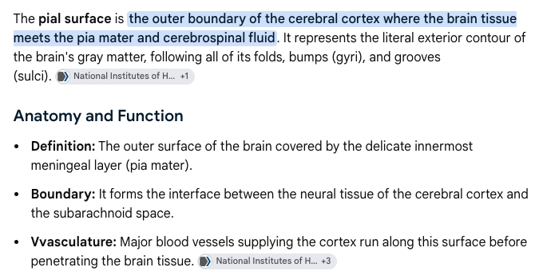
2. 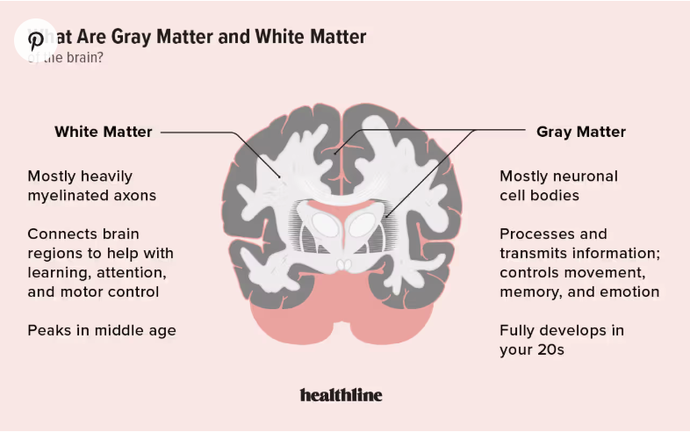
Morphology : The study of form and structure.

